SINDy for Infectious Disease Data
Complete Visual Guide with Formulas, Diagrams & Code

Based on: Horrocks & Bauch (2020), Scientific Reports
DOI: 10.1038/s41598-020-63877-w

Every formula explained • Every diagram included • Every code function mapped

1. The Problem: Two Ways to Build a Disease Model
Traditional disease modeling is deductive – a scientist hypothesizes mechanisms, writes equations, fits parameters, and tests predictions. If wrong, they start over. This is slow, and biased by what the scientist already believes.
SINDy flips it. It is inductive – start from raw case data, let an algorithm figure out which mathematical terms actually govern the dynamics, and produce the equations automatically. No prior epidemiological knowledge needed.

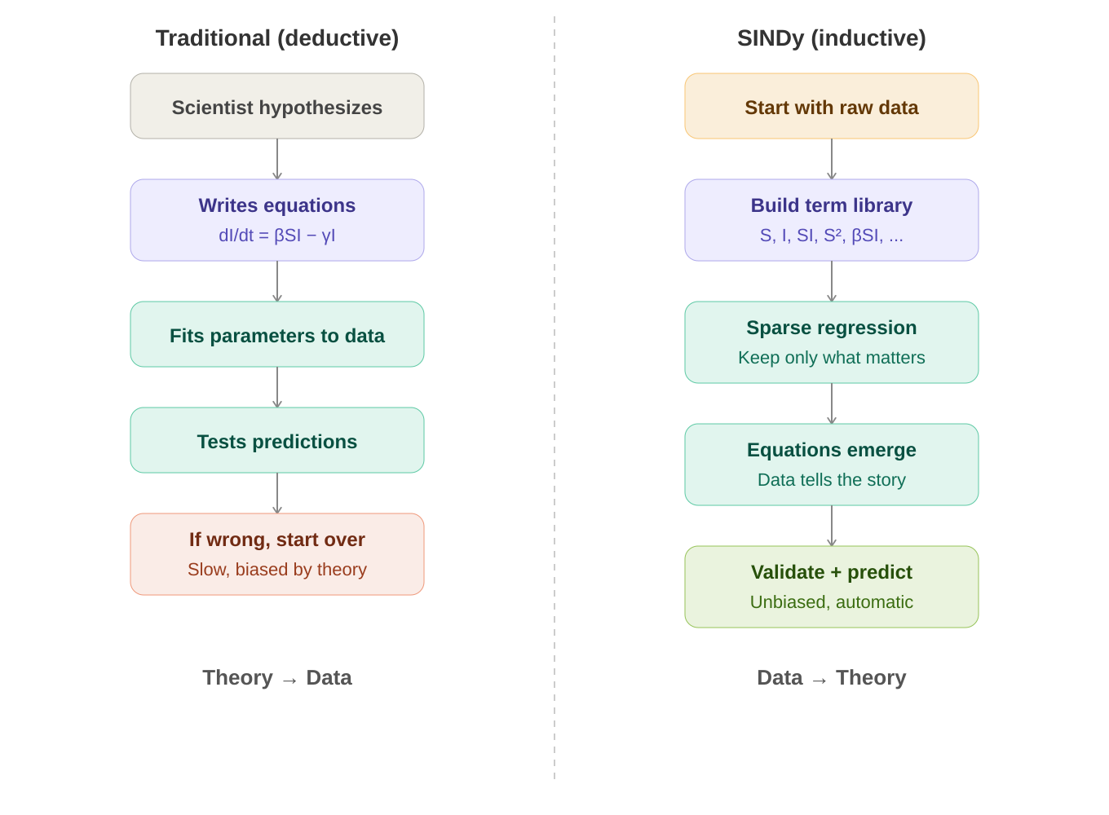

The core question: Can a machine learning algorithm independently discover the fundamental mechanisms of disease transmission – mechanisms that epidemiologists spent decades figuring out?

2. The Data Pipeline: From Raw Cases to SINDy Input
SINDy needs two clean time series as input: I(t) – the number of infectious people over time, and S(t) – the number of susceptible people over time. Getting there from raw weekly case counts requires several transformation steps.

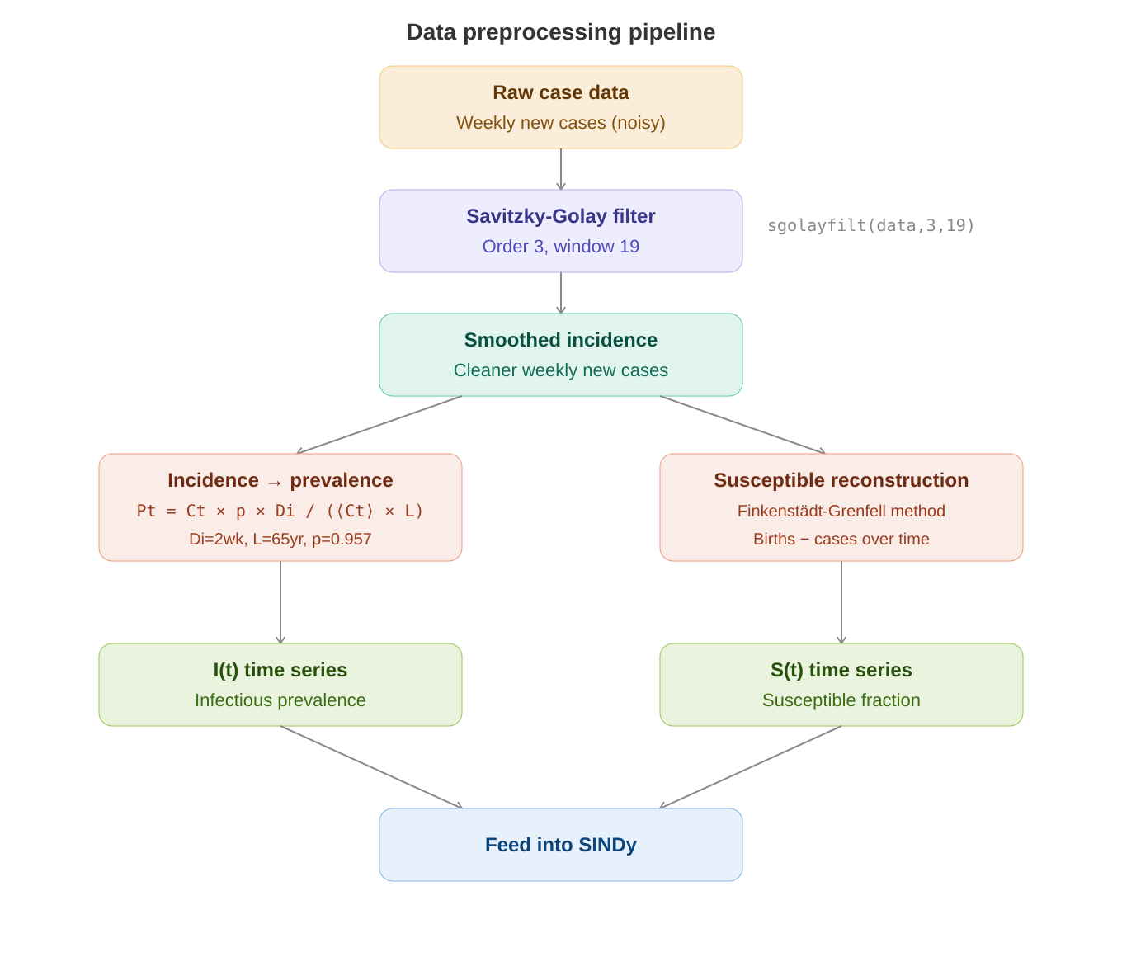

2.1 The Three Diseases Studied
Disease | Location | Years | Cycle Pattern
Measles | England & Wales | 1948–1967 | Biennial (every 2 years)
Chickenpox | Ontario, Canada | 1946–1967 | Annual (every year)
Rubella | Ontario, Canada | 1946–1960 | Multiennial (5–7 years)

All data comes from the International Infectious Disease Data Archive (IIDDA) at McMaster University. These are pre-vaccine era records, meaning disease dynamics are purely natural.

2.2 Formula: Incidence to Prevalence Conversion
P_t = C_t × p × D_i / (⟨C_t⟩ × L)
Converts weekly new cases (incidence) into total currently infected (prevalence). C_t = cases in week t, p = 0.957 (lifetime infection probability), D_i = 2 weeks (infection duration), L = 65 years (mean lifespan), ⟨C_t⟩ = average cases.

Formula / Symbol | What it means
C_t | Number of new cases reported in week t
P_t | Prevalence – proportion of population currently infected at time t
D_i = 2 weeks | Average duration of infectiousness for measles/chickenpox/rubella
L = 65 years | Mean individual lifespan
p = 0.957 | Proportion of people who contract the infection in their lifetime
⟨C_t⟩ | Time-averaged mean of weekly case counts

MATLAB code: P = C .* p .* Di ./ (mean(C) .* L);

2.3 Formula: Susceptible Reconstruction (Finkenstädt-Grenfell Method)
S_{t+1} = S_t – α_t × C_{t,t+1} + B_{t-d,t-d+1} + u_t
Each week, the susceptible pool gains new births (B) and loses new infections (α × C). α_t is the time-varying reporting rate, d is the birth-to-susceptibility delay, u_t is noise.

Y_t = α̅ × X_t + (Z_t – Z_0) [simplified linear form]
Cumulative births (Y_t) vs. cumulative cases (X_t). Linear regression gives the average reporting rate α̅ (slope) and susceptible deviations Z_t – Z_0 (residuals).

Formula / Symbol | What it means
S_t | Number of susceptible people at week t
α_t | Reporting rate – fraction of true cases that get reported (changes over time)
C_{t,t+1} | New cases reported between week t and t+1
B_{t-d,t-d+1} | Births between week t-d and t-d+1 (delayed by d weeks)
X_t = Σ C_{i,i+1} | Cumulative cases up to time t
Y_t = Σ B_{i-d,i-d+1} | Cumulative births up to time t
Z_t = S_t – S̅ | Deviation of susceptibles from their mean value

3. The SINDy Algorithm: Step by Step
SINDy (Sparse Identification of Nonlinear Dynamics) works by building a large library of candidate mathematical terms, then using iterative sparse regression to eliminate the unimportant ones. Only the essential mechanisms survive.

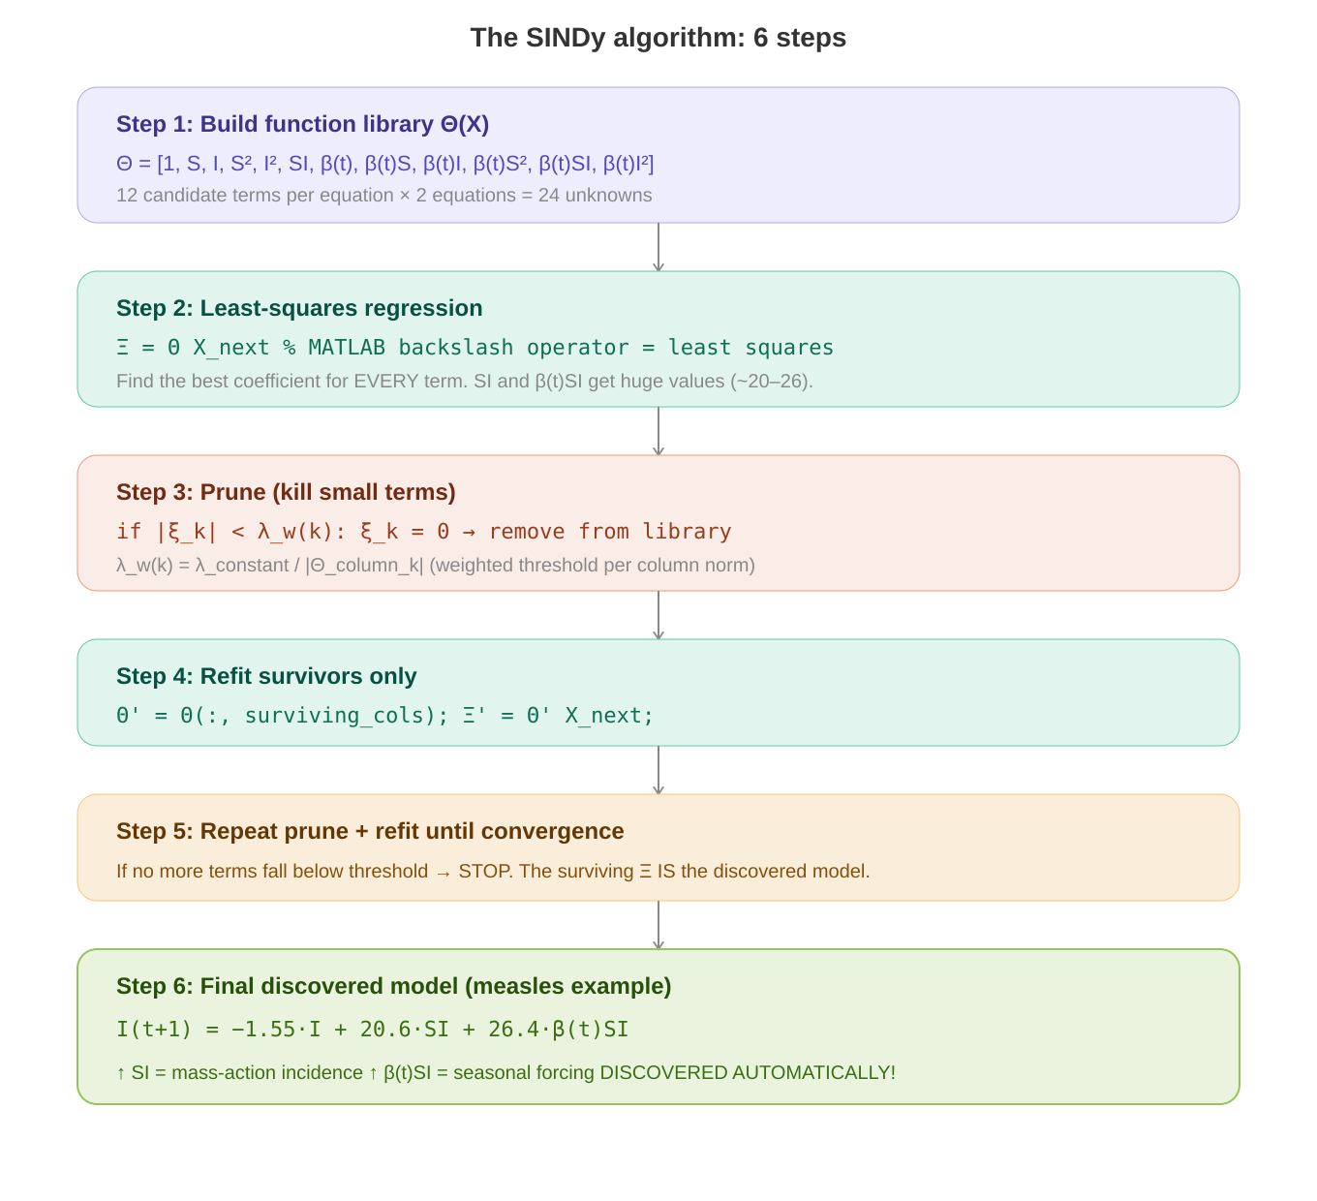

3.1 Formula: The Core Regression Problem
Ẋ = Θ(X) × Ξ
The entire SINDy problem in one line. Ẋ is the derivative (or next-step state). Θ(X) is the function library matrix. Ξ is the sparse coefficient matrix we want to find.

Formula / Symbol | What it means
X | Data matrix: each row is a time step, columns are state variables [S_t, I_t]
Ẋ (or X_{t+1}) | Response: the next-step values (discrete-time) or derivatives (continuous-time)
Θ(X) | Function library: each column is a candidate term (1, S, I, S², SI, βSI, ...) evaluated at every timestep
Ξ = [ξ_1, ξ_2, ..., ξ_p] | Coefficient matrix: one sparse column per equation. THIS is the discovered model.
p | Total number of candidate terms in the library (12 for 2nd-order, 20 for 3rd-order)

3.2 The Function Library Θ(X)
For the 2nd-order polynomial library with seasonal forcing:
Θ(X) = [1, S, I, S², I², SI, β(t), β(t)S, β(t)I, β(t)S², β(t)SI, β(t)I²]
12 candidate terms. The first 6 are constant-coefficient polynomials. The last 6 are the same polynomials multiplied by the seasonal forcing function β(t). Each term is evaluated at every timestep to create a column of the Θ matrix.

3.3 Formula: Seasonal Forcing Function
β(t) = β₀(1 + β₁ × cos(2πt/T – φ))
The transmission rate oscillates with the seasons. Peaks when schools open (autumn), troughs in summer holidays.

Formula / Symbol | What it means
β(t) | Time-varying transmission rate at week t
β₀ | Mean (baseline) transmission rate across the year
β₁ | Amplitude of seasonal variation (0 = no seasonality, 1 = huge effect)
T = 1 year = 52 weeks | Period of the seasonal oscillation
φ (phi) | Phase shift – when in the year the peak occurs. Swept from 0 to 52 weeks.

3.4 Formula: Weighted Thresholding (Key Innovation)
λ_w(k) = λ_c / |Θ^(k)(X)|
Standard SINDy uses a fixed threshold λ for all terms. But epidemiological variables span different scales (S ~ 0.1, I ~ 0.0001). This weighted version scales the threshold by each column’s L2-norm, treating all terms fairly.

Formula / Symbol | What it means
λ_w(k) | Weighted threshold for the k-th term in the library
λ_c | Constant base threshold (the ‘sparsity knob’ swept from 0.0001 to 0.1)
|Θ^(k)(X)| | L2-norm (magnitude) of the k-th column of the function library
Rule | If |coefficient_k| < λ_w(k), then that term is eliminated (coefficient set to 0)

3.5 The sparsifyDynamics() Function – Line by Line
This is the heart of the entire codebase. Here is exactly what it does:
- Input: Θ (library matrix), X_next (target data), λ (threshold)
- Perform least-squares: Ξ = Θ \ X_next (MATLAB backslash operator)
- For each column k of Ξ: compute λ_w(k) = λ / norm(Θ_column_k)
- For each coefficient ξ: if |ξ| < λ_w, set ξ = 0
- Remove zeroed columns from Θ to create smaller Θ′
- Repeat steps 2–5 with Θ′ until no more terms are eliminated (convergence)
- Output: Sparse coefficient matrix Ξ with most entries = 0. The nonzero entries ARE the discovered model.

3.6 Formula: Model Selection with AIC
AIC_i = 2k – 2 ln(L(x, μ̂))
Balances goodness-of-fit (L) against model complexity (k). Lower AIC = better. A model with fewer terms that fits almost as well will beat a complex model.

Formula / Symbol | What it means
AIC_i | Akaike Information Criterion score for candidate model i
k | Number of free (nonzero) parameters in the model
L(x, μ̂) | Likelihood of the observed data x given the best-fit parameters μ̂
ln(L) | Log-likelihood – how well the model explains the data
2k penalty | Complexity cost – each extra parameter adds +2 to AIC

3.7 Formula: Sparsity Index
r = 1 – ||Ξ||_0 / ||Θ||_0
Ratio of eliminated terms to total library terms. r = 0 means nothing was eliminated (dense). r = 1 means everything was eliminated. A good discovered model has moderate r (0.25 to 0.7).

4. The Parameter Grid Search
Two critical unknowns – the initial susceptible fraction S₀ and the sparsity threshold λ – are searched across a 2D grid. At each grid point, SINDy also sweeps the seasonal phase shift φ. The model with the lowest AIC wins.

Parameter | Range | Purpose
S₀ (initial susceptibles) | 0.05 to 0.13 | Fraction of population initially susceptible – affects dynamics
λ (sparsity knob) | 0.0001 to 0.1 | Threshold for eliminating terms – controls model complexity
φ (phase shift) | 0 to 52 weeks (step 0.5) | When seasonal transmission peaks – must match school calendar

λ too low (0.0001): All 12 terms survive → overfitting, model captures noise.
λ optimal (0.005 for measles): 6 terms survive → biennial cycle recovered, mass-action + seasonal forcing found.
λ too high (0.1): Too many terms killed → essential dynamics lost, annual cycle instead of biennial.

5. Results: What SINDy Discovered

5.1 Measles – The Best Result
Best parameters: S₀ = 0.11286, λ = 0.00517, sparsity r = 0.25

Discovered I equation (simplified):
I(t+1) = −1.55·I + 20.6·SI + 26.4·β(t)SI
SI = mass-action incidence (the core of ALL epidemic models). β(t)SI = seasonally-forced transmission. Both discovered automatically from data alone!

Term | S equation coeff. | I equation coeff. | Interpretation
1 (constant) | 0.025 | 0.002 | Baseline offset
S | 0.606 | −0.037 | Close to 1 – expected for discrete-time
I | 1.084 | −1.554 | Demographic/recovery processes
S² | 1.541 | 0.139 | NEW: Causes subexponential growth
SI | −10.295 | 20.618 | MASS-ACTION INCIDENCE – the core mechanism!
β(t)SI | 26.409 | 0 | SEASONAL FORCING – schools drive epidemics!
β(t)I | −3.122 | 0 | Seasonal recovery effect

- Biennial (2-year) epidemic cycle perfectly reproduced
- Out-of-sample prediction: reducing birth rate shifts dynamics from biennial to noisy annual – matches real post-vaccine UK data
- S² term is a novel discovery: causes slow epidemic ramp-up then rapid decline, matching real data but absent from standard SIR models

5.2 Chickenpox – Overfitting Problem
Issue: The β(t)I² term has coefficient 114.8 in the I equation – the largest of all, but biologically meaningless.

- Annual cycle captured correctly
- SI and βSI terms present with meaningful coefficients
- BUT β(t)I² dominates – ‘seasonally varying infectious-squared’ has no known biological interpretation
- Why? Chickenpox has a SIMPLE annual cycle. A sine wave alone can fit it. SINDy overfits by using complex terms to mimic what a simpler model could explain.

5.3 Rubella – Required PSD Approach
- Baseline approach FAILED: SINDy returned annual cycle instead of observed 5–7 year cycle
- PSD approach FIXED IT: fitting power spectral density instead of raw time series
- With PSD: multiennial outbreaks recovered, mass-action terms dominate (SI = 23.8, βSI = 25.6)
- S² term reappears (0.15) – same novel mechanism as measles

5.4 Formula: Power Spectral Density Approach (Rubella Fix)
AIC_PSD = 2k + n × ln(RSS_PSD / n)
where RSS_PSD = Σ(PSD_data – PSD_model)²
Instead of comparing raw time series, compare the FREQUENCY CONTENT of model vs data. This selects models that match qualitative dynamics (correct cycle lengths) even if exact outbreak timing differs.

PSD computation steps in MATLAB:
- Smooth infection time series: smooth(I_data, 23) – moving average, window 23
- Remove linear trend: detrend(data_smooth)
- Taper 20% of edges: split cosine bell
- Compute periodogram: [psd, freq] = periodogram(data_tapered)
- Calculate AIC from PSD residuals instead of time-series residuals

6. The Complete Code Architecture
The entire codebase is MATLAB, hosted at github.com/jonathanhorrocks/SINDy-data. It is a modification of Brunton et al.’s original SINDy code (sparsedynamics.zip). Here is the full pipeline:

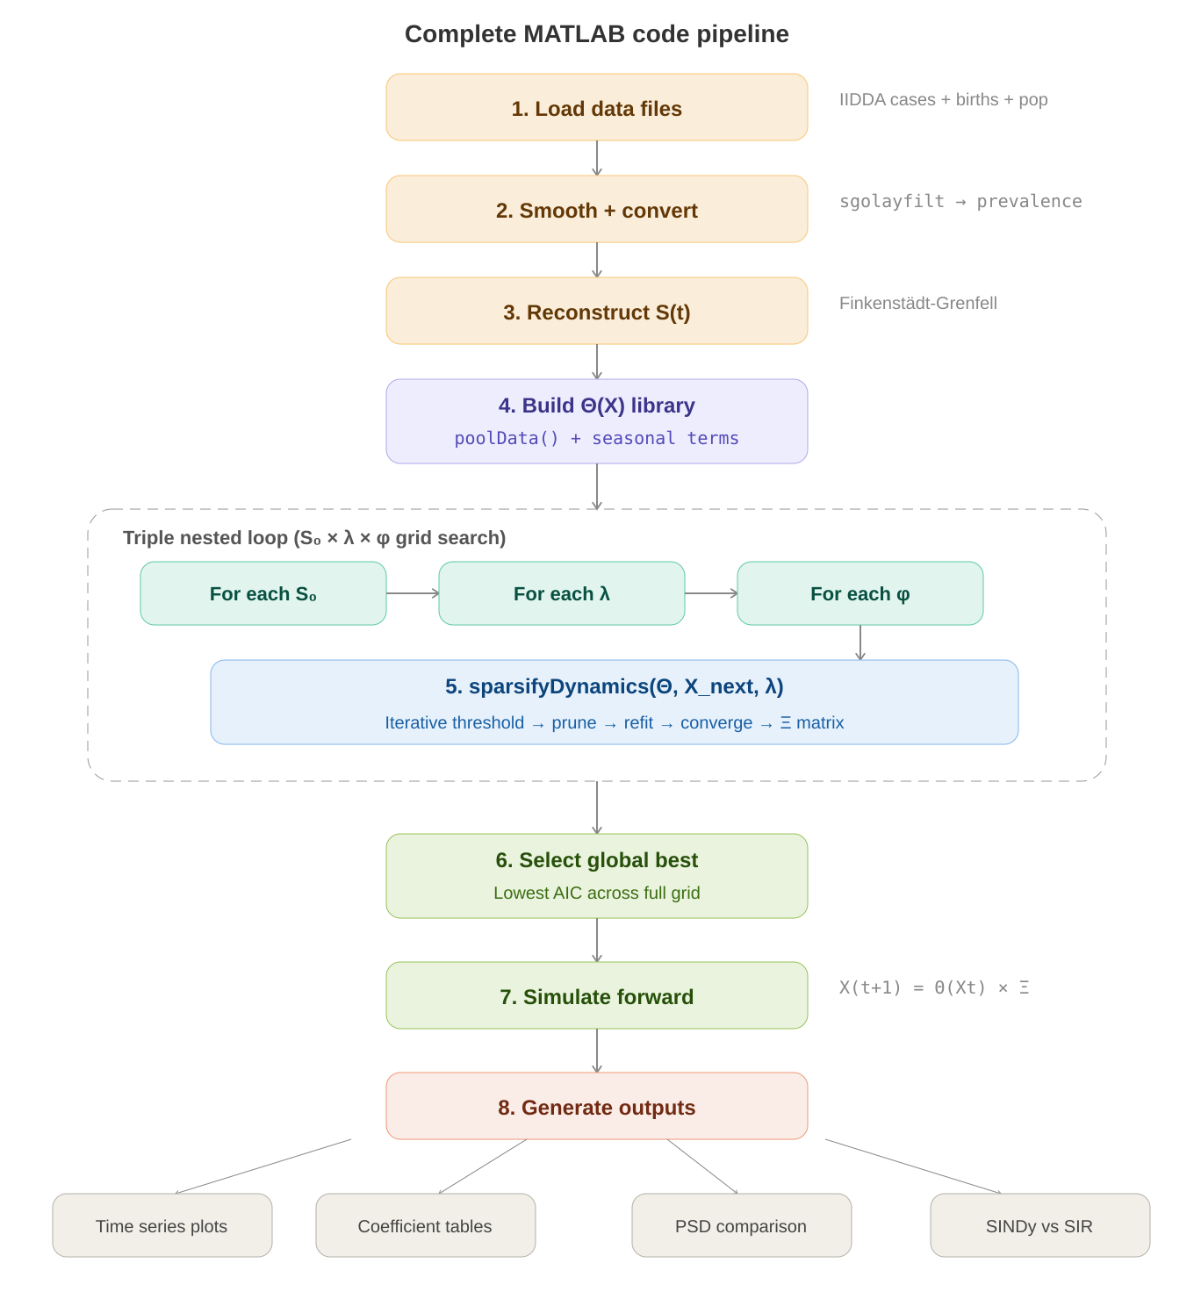

6.1 Key MATLAB Functions
Function | What it does | Input → Output
poolData() | Builds the function library Θ(X) | State variables → Matrix of candidate terms
poolDataList() | Returns human-readable names for each library term | Order → String labels
sparsifyDynamics() | THE core algorithm: iterative sparse regression | Θ, X_next, λ → Sparse Ξ
SparseGalerkin() | Simulates the discovered model forward in time | Ξ, initial conditions → Time series
sgolayfilt() | Savitzky-Golay smoothing filter (built-in MATLAB) | Noisy data → Smooth data
periodogram() | Computes power spectral density (built-in MATLAB) | Time series → PSD estimate

6.2 Code Flow with Pseudocode
Here is the entire pipeline as executable logic:

% Stage 1-3: Load and preprocess
data = load('measles_cases.mat');
cases_smooth = sgolayfilt(data.cases, 3, 19);
I_t = cases_smooth .* p .* Di ./ (mean(cases_smooth) .* L);
S_t = reconstruct_susceptible(cases_smooth, births);

% Stage 4: Build library
Theta = poolData([S_t, I_t], 2); % 2nd order polynomials
Theta = [Theta, beta_t .* Theta]; % Add seasonal terms

% Stage 5: Grid search + SINDy
for S0 = 0.05 : 0.01 : 0.13
for lambda = 0.0001 : ... : 0.1
for phi = 0 : 0.5 : 52
Xi = sparsifyDynamics(Theta, X_next, lambda);
aic(S0,lambda) = compute_AIC(Xi, data);
end
end
end

% Stage 6-8: Select best + simulate + plot
[best_S0, best_lambda] = find(min(aic));
Xi_best = models(best_S0, best_lambda);
X_sim = SparseGalerkin(Xi_best, X0, tspan);
plot(X_sim); hold on; plot(data); % Compare!

7. Complete Formula Reference
Every formula in the paper, collected in one place with full explanations.

7.1 The Discrete-Time SIR Model (Equations 1–4)
S_{t+1} = S_t + ν – β(t)·S_t·I_t – μ·S_t
Susceptibles next week = current susceptibles + births (ν) – new infections (βSI) – deaths (μS)

I_{t+1} = I_t + β(t)·S_t·I_t – γ·I_t – μ·I_t
Infectious next week = current infectious + new infections – recoveries (γI) – deaths (μI)

R_{t+1} = R_t + γ·I_t – μ·R_t
Recovered next week = current recovered + new recoveries – deaths

Formula / Symbol | What it means
S_t, I_t, R_t | Susceptible, Infectious, Recovered population at week t
ν (nu) | Per capita birth rate per timestep
μ (mu) | Per capita death rate per timestep (ν = μ for constant population)
β(t) | Seasonally-varying transmission rate
γ (gamma) | Per capita recovery rate per timestep (1/γ = infection duration)
β(t)·S_t·I_t | MASS-ACTION INCIDENCE – the fundamental transmission mechanism

7.2 The SINDy Regression (Equations 5–9)
ẋ = f(x(t), t) [Equation 5]
General form: the system’s dynamics are governed by some unknown function f of the state x and time t.

Ẋ = Θ(X) × Ξ [Equation 7]
The SINDy regression problem: find the sparse coefficient matrix Ξ such that the library Θ times Ξ approximates the response.

ẋ_k = Θ(x_kᵀ) × ξ_k [Equation 8]
Reconstruct the k-th equation of the discovered dynamical system.

ẋ = Ξᵀ × Θ(xᵀ)ᵀ [Equation 9]
The full reconstructed system of equations – this IS the discovered model.

7.3 All Other Key Formulas
AIC_i = 2k – 2·ln(L(x, μ̂)) [Equation 10]
Akaike Information Criterion for model selection.

P_t = C_t·p·D_i / (⟨C_t⟩·L) [Equation 20]
Incidence to prevalence conversion.

λ_w(k) = λ_c / |Θ^(k)(X)| [Equation 21]
Weighted thresholding – scales the sparsity threshold by each column’s norm.

β(t) = β₀(1 + β₁·cos(2πt/T – φ)) [Equation 22]
Seasonal forcing function for the transmission rate.

r = 1 – ||Ξ||_0 / ||Θ||_0
Sparsity index: fraction of library terms with zero coefficients in the discovered model.

8. Key Takeaways
- SINDy discovered mass-action incidence (βSI) and seasonal forcing – the two pillars of epidemic modeling – automatically from data, confirming decades of epidemiological theory through a completely different approach.
- The measles model predicted a real-world regime shift (biennial → annual cycle) out-of-sample, proving it captured real mechanisms and not just noise.
- A novel S² term was discovered that causes subexponential early epidemic growth – something standard SIR models miss but the data clearly shows.
- Chickenpox overfitting shows SINDy struggles when true dynamics are simple (an annual sine wave doesn’t need complex nonlinear terms).
- Rubella required fitting frequency content (PSD) instead of raw time series – matching qualitative dynamics rather than exact timing.
- The weighted thresholding innovation is essential for epidemiological data where state variables span different orders of magnitude.
- Model discovery is a powerful COMPLEMENT to traditional modeling, not a replacement. Subject expertise is still needed to interpret discovered models.

Code Repository: github.com/jonathanhorrocks/SINDy-data (MATLAB)
Original SINDy: faculty.washington.edu/sbrunton/sparsedynamics.zip
Python Alternative: github.com/dynamicslab/pysindy (PySINDy package)
Data Source: International Infectious Disease Data Archive – iidda.mcmaster.ca

